Query Cache
MySQL query cache stores query results of frequently and recently run queries so they can be returned quickly without processing everything from scratch. They are very useful in improving query speed and database performance.

How To Enable MySQL Query Cache
Here is MySQL Query cache configuration for your database.

1. Check Availability
Log into MySQL and run the following command to check if MySQL query cache is available for your database.
mysql> SHOW VARIABLES LIKE 'have_query_cache';
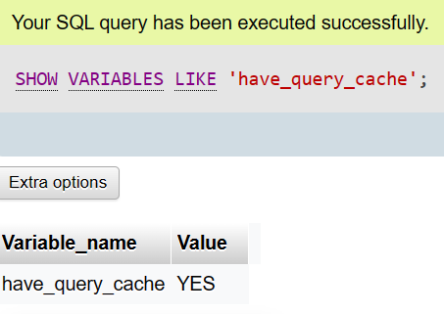

Default Query Cache Variables
MySQL query cache is controlled by many variables. Run the following command to view their default values first, before changing them.
mysql> show variables like 'query_cache_%' ;
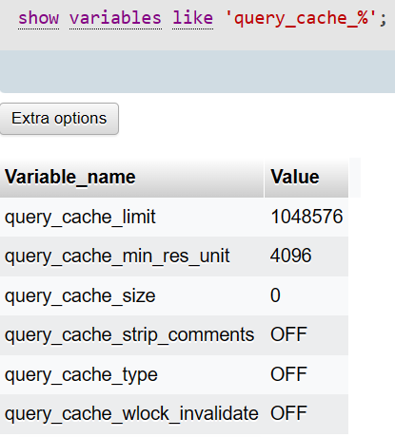

Let us look at the above query cache variables,
- query_cache_limit – It displays the maximum size of query results that can be cached. The default value is 1MB. We can set it up to 4GB. However, we don’t advise high values.
- query_cache_min_res_unit– MySQL stores query result in blocks. This is the minimum size of each block.
- query_cache_size – It displays the overall memory allotted for the MySQL cache. 1MB is the default setting. We can set it up to 4GB taking into account our needs. However, we don’t advise high values.
- query_cache_type – setting this to 0 or OFF disables MySQL query cache. setting it to 1 enables query cache.
- query_cache_wlock_invalidate – determines if MySQL should fetch results from cache if the underlying table is locked.

Enable MySQL Query Cache

$ sudo vi /etc/mysql/my.cnf
Add the following lines below [mysqld] section
...
[mysqld]
query_cache_type=1
query_cache_size = 10M
query_cache_limit=256K
We have enabled query cache by setting query_cache_type variable to 1, with individual query cache as 256Kb and total cache as 10Mb

Restart MySQL database
Restart MySQL to apply changes
$ sudo systemctl restart mysql
OR
$ sudo service mysql restart
OR
$ sudo /etc/init.d/mysql restart

Examples
MySQL Query Cache is normally responsible for tuning the MySQL performance and one can view the variables of query cache in the database server using the following commands:
SHOW VARIABLES LIKE 'have_query_cache';
show variables like 'query_cache_%' ;
SET GLOBAL query_cache_limit = 1048576;
SET GLOBAL query_cache_size = 1048576;
show variables like 'query_cache_size';
Query cache is an important feature for query optimization improving performance. You can also display the status of query cache variable working in the server as:
SHOW STATUS LIKE 'qcache%';

The MySQL query cache is defined as a query results cache. It matches the incoming queries which initialize with SEL to a hash table, then if there exists a match it will return from the preceding execution of the query.

